LAB #10
Efe Emir Cesur
Student ID #: 22608
Lab Section: A
1. Introduction
The primary objectives of this experiment were to extract the unknown parameters of a BS170 NMOS transistor and to design, implement, and analyze a common-source (CS) amplifier circuit. Initially, the threshold voltage (VT) and conduction parameter (Kn) of the NMOS transistor were determined by measuring the drain current (ID) and gate-to-source voltage (VGS) under different DC bias conditions. Following the parameter extraction, a common-source amplifier was constructed. The DC operating point node voltages at the gate, source, and drain terminals were measured and compared with theoretical calculations. Furthermore, a 1 kHz sinusoidal input signal was applied to observe signal amplification, determine the voltage gain, and sketch the Bode plot by measuring the gain across various frequencies to identify the lower and upper cut-off frequencies (fL and fH). Standard laboratory equipment, including a DC power supply, waveform generator, oscilloscope, and multimeters, were utilized throughout the experiment.
2. Pre-Lab Work
Figure 1: Common-source amplifier
For the pre-lab work, Q point of the figure 1 calculated for VS+ = 5 V, VS- = -5V, R1 = 200 kΩ, R2 = 100 kΩ, RS1 = 240 Ω, RD1 = RL = 1 kΩ and CC = CL = CS = 100 μF. Also DC Voltages at the Gate, Source and Drain terminals with respect to common node calculated. DC load line sketched, using small signal model of NMOS; voltage gain, lower 3-db and upper 3-db are calculated. Design simulated in LTSpice to DC find operating points and voltage gain. 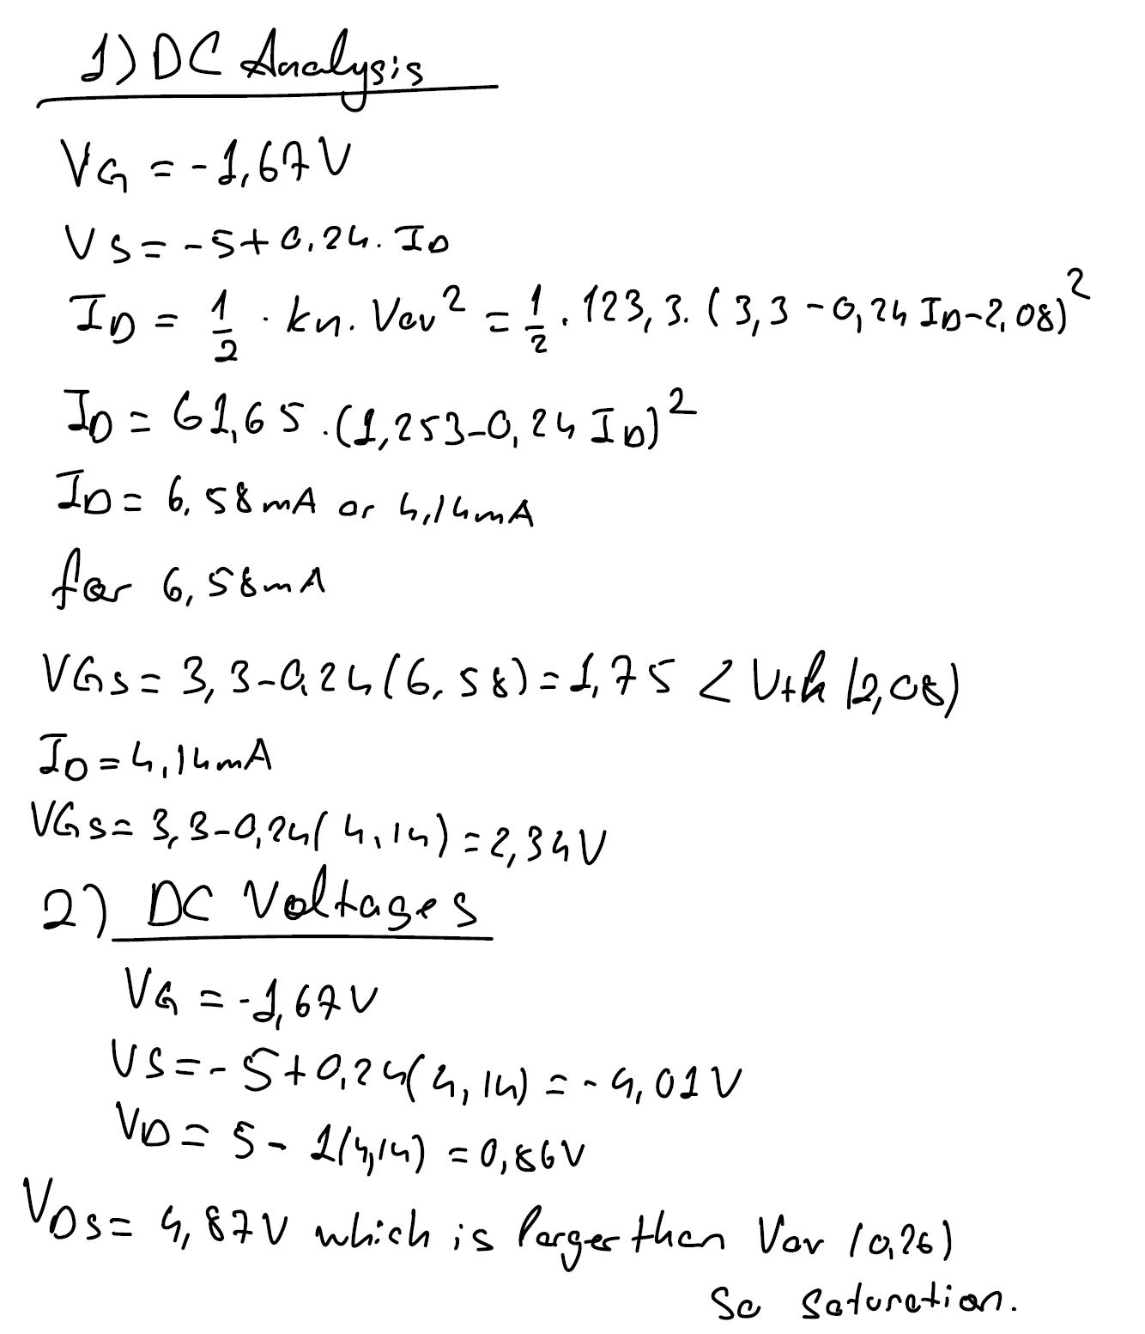
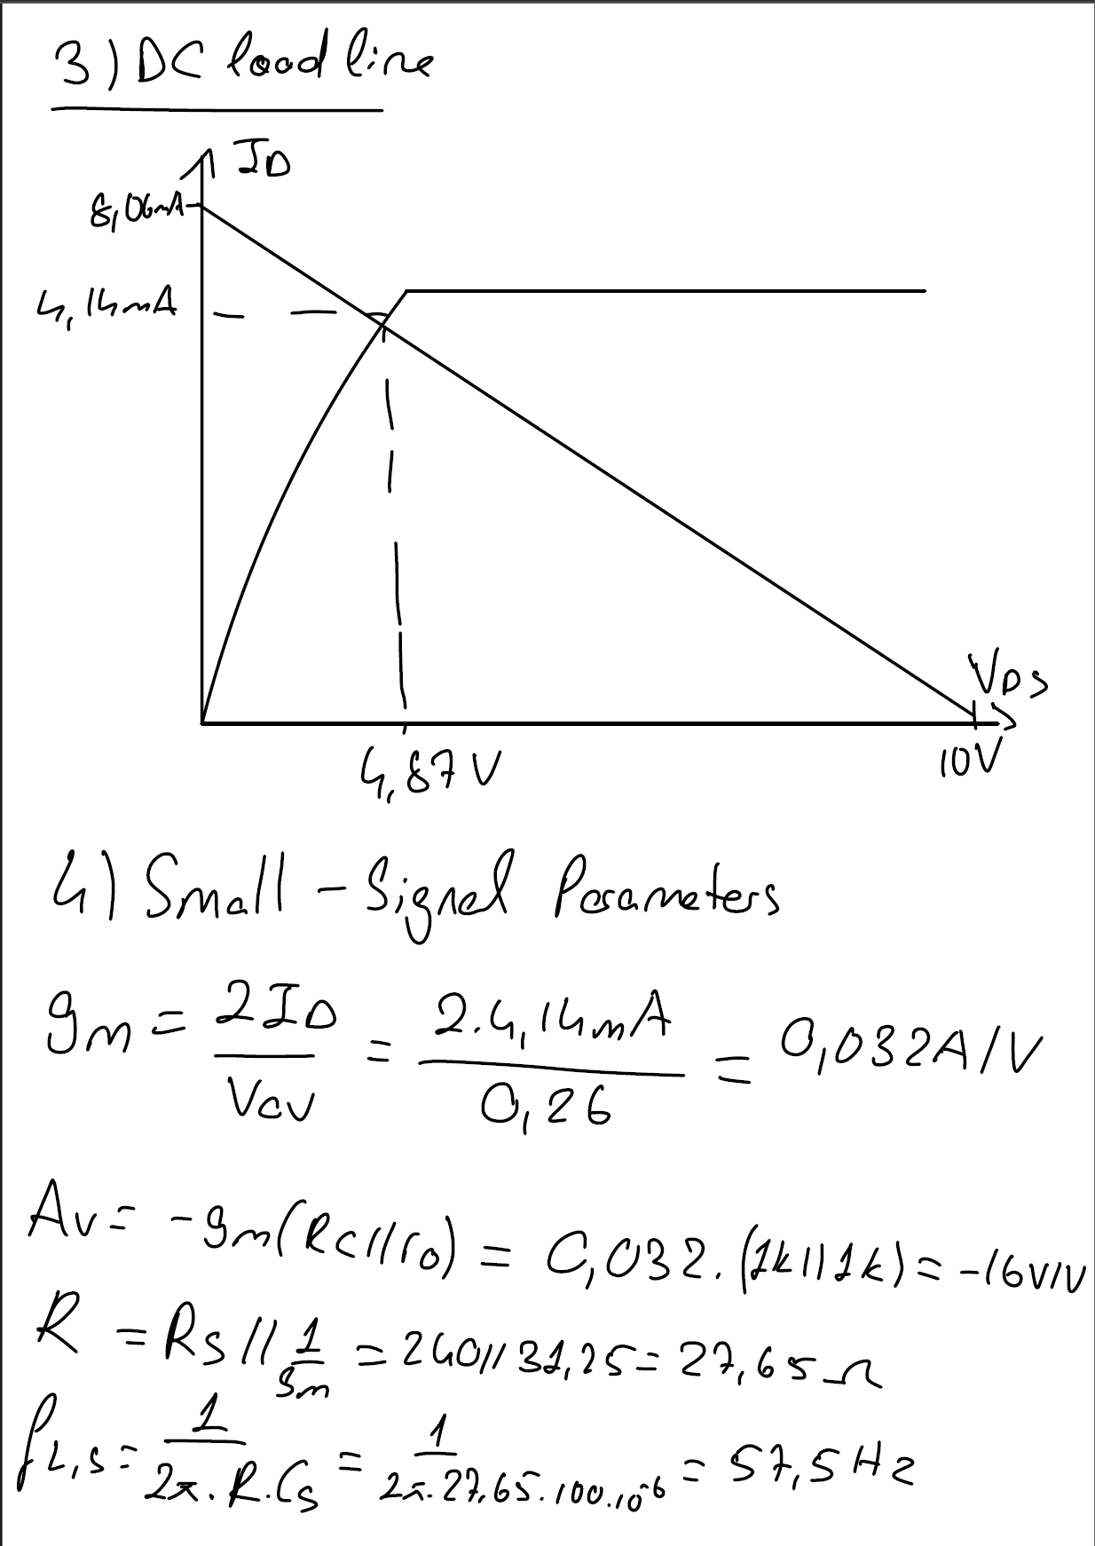
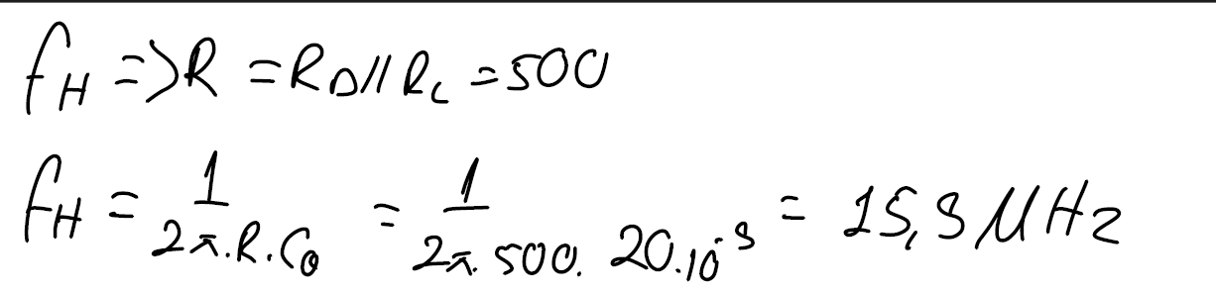
Figure 2: Circuit in LTSpice
Figure 3: DC Voltages at the nodes
Figure 4: Bode plot of the circuit in LTSpice
3. Data / Results
Part 1: Determination of Conducting Parameter and Threshold Voltage
Figure 5
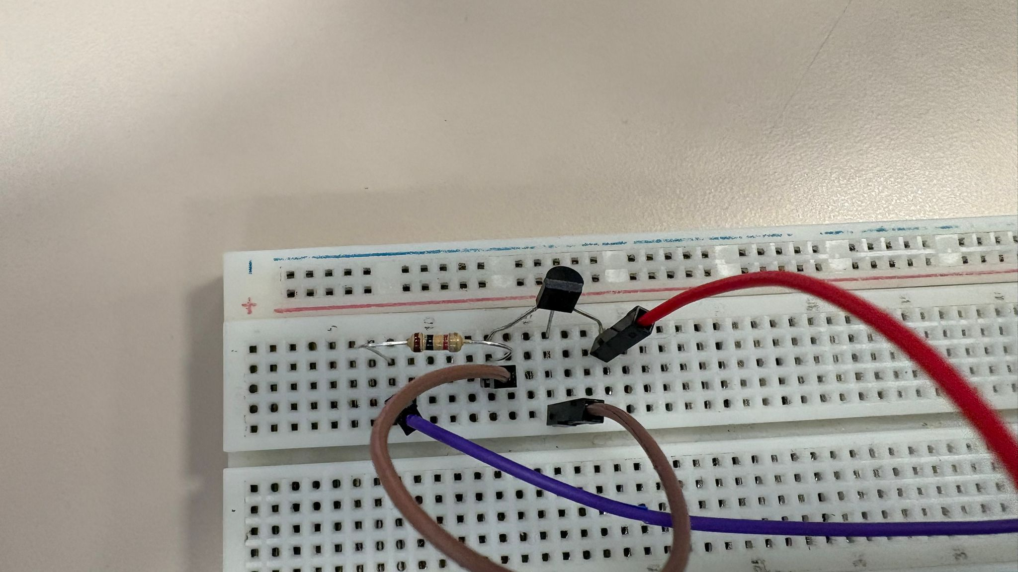Circuit connected as shown in Figure 5. Voltage adjusted until voltage drop across the 1K ohm resistor is about 2V then drain current calculated. Also VGS and VDS is measured. After that Voltage adjusted about 4V across the resistor and values calculated again. Then threshold voltage calculated using the formula:
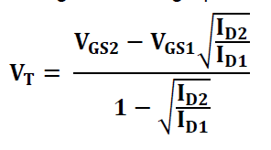Figure 6: Threshold voltage formula
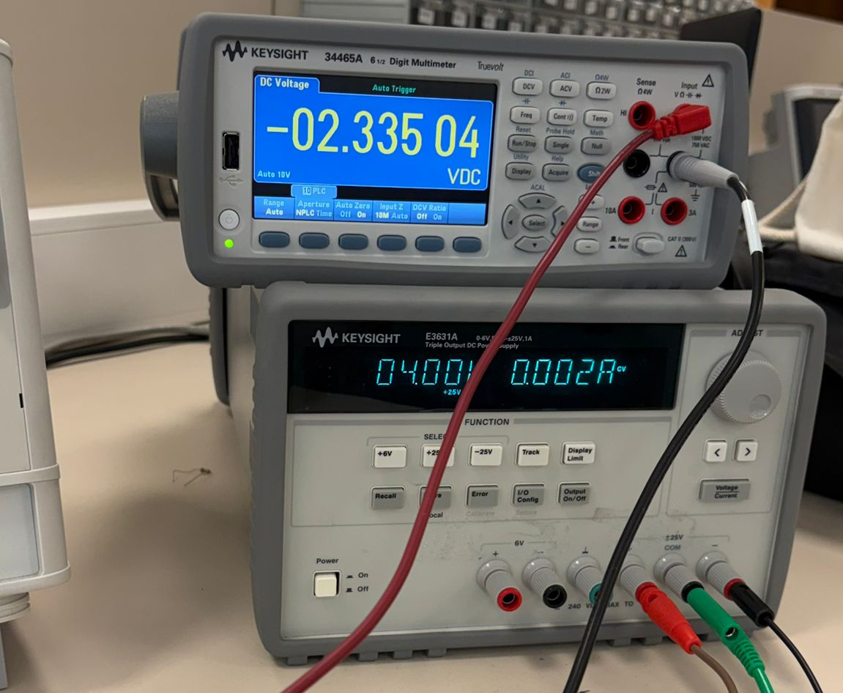Figure 7: Voltage drop across resistor at 4V
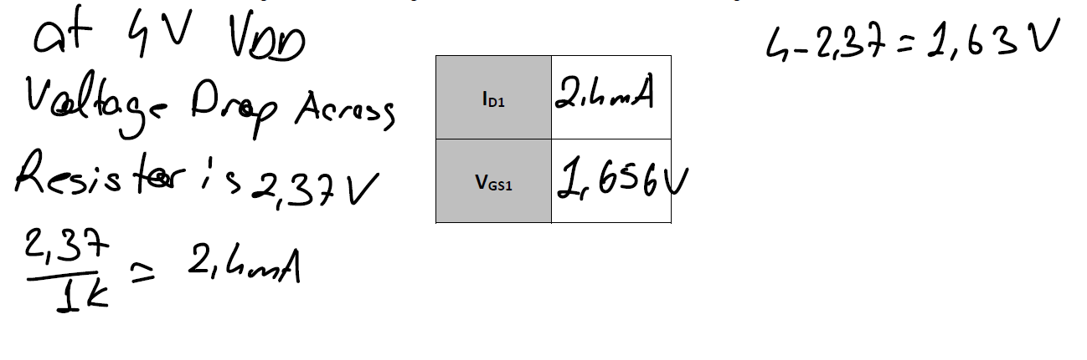
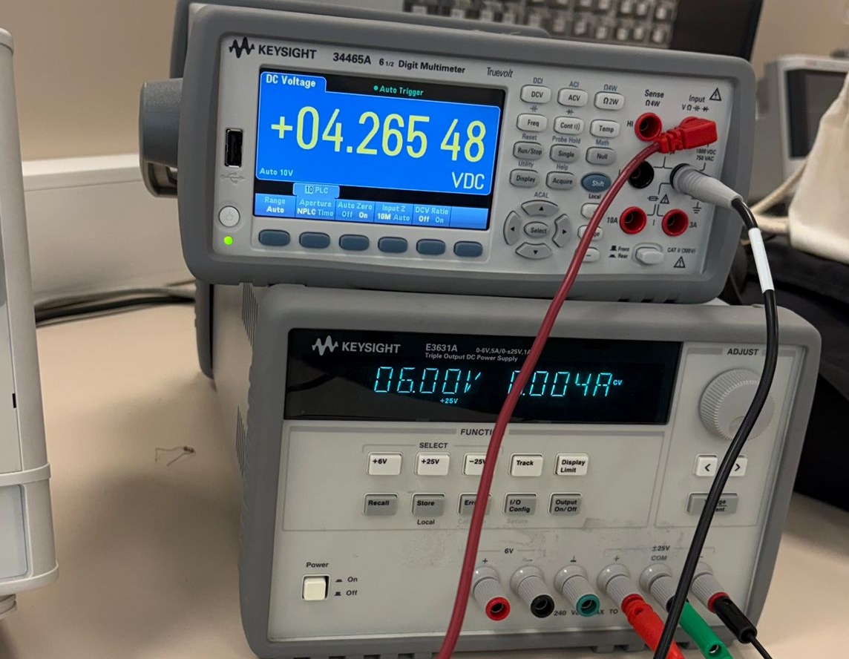
Figure 8: Voltage drop across resistor at 6V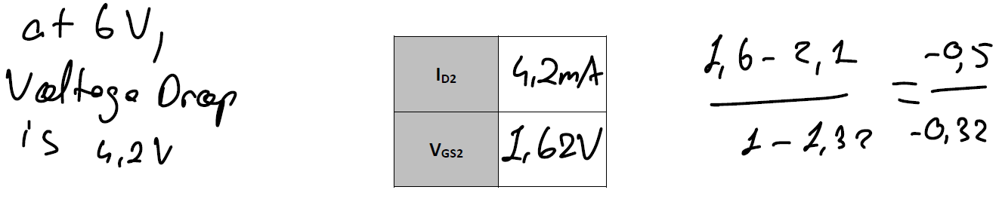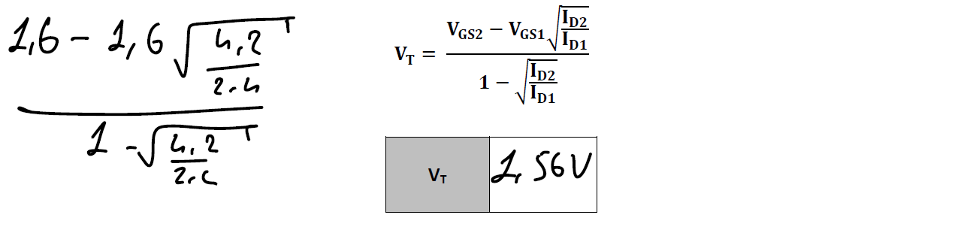
After that conduction parameter Kn computed using the formula:
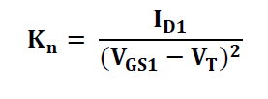
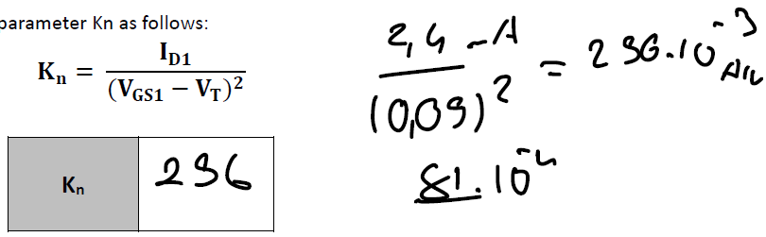
For the last part ID2 calculated and compared to measurements using the formula:
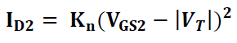
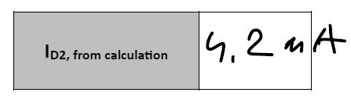

Part 2: Common-Source Amplifier Implementation
Circuit in Figure 1 is builted using +5V and -5V, Voltage values measured at the Gate, Source and Drain and compared with theoretically determined values and error percentage is computed.
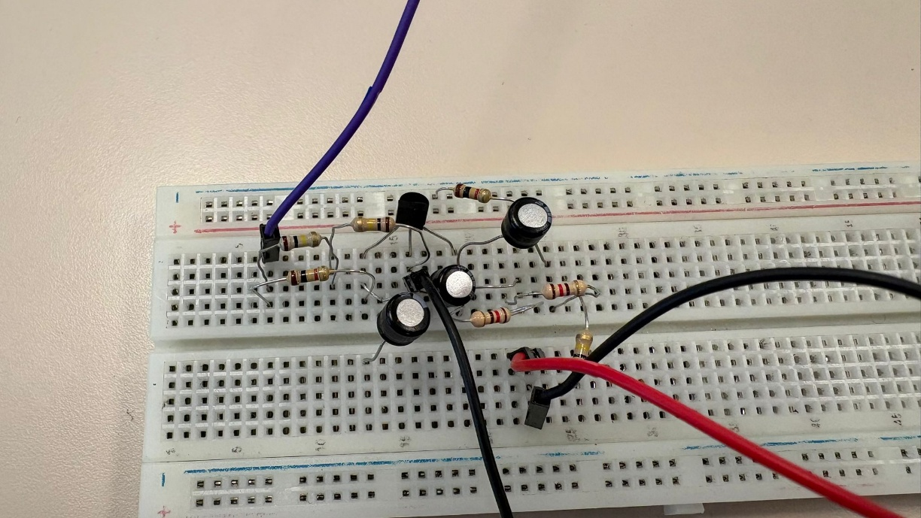
Figure 9: Circuit in Figure 1 is built.

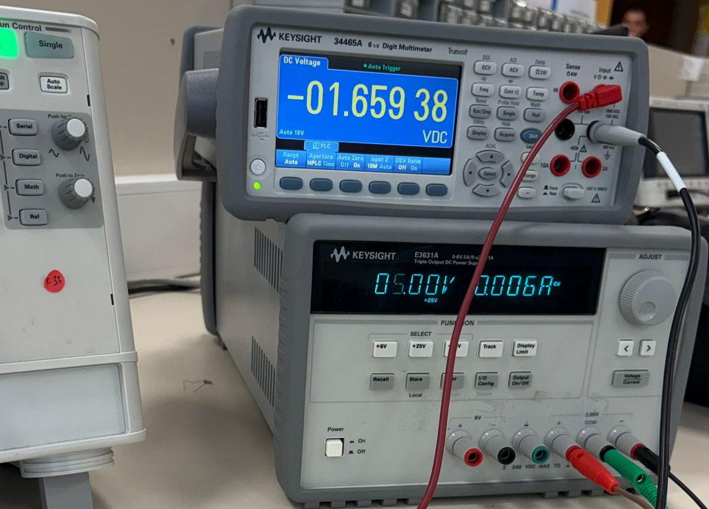
Figure 10: Voltage at the gate terminal
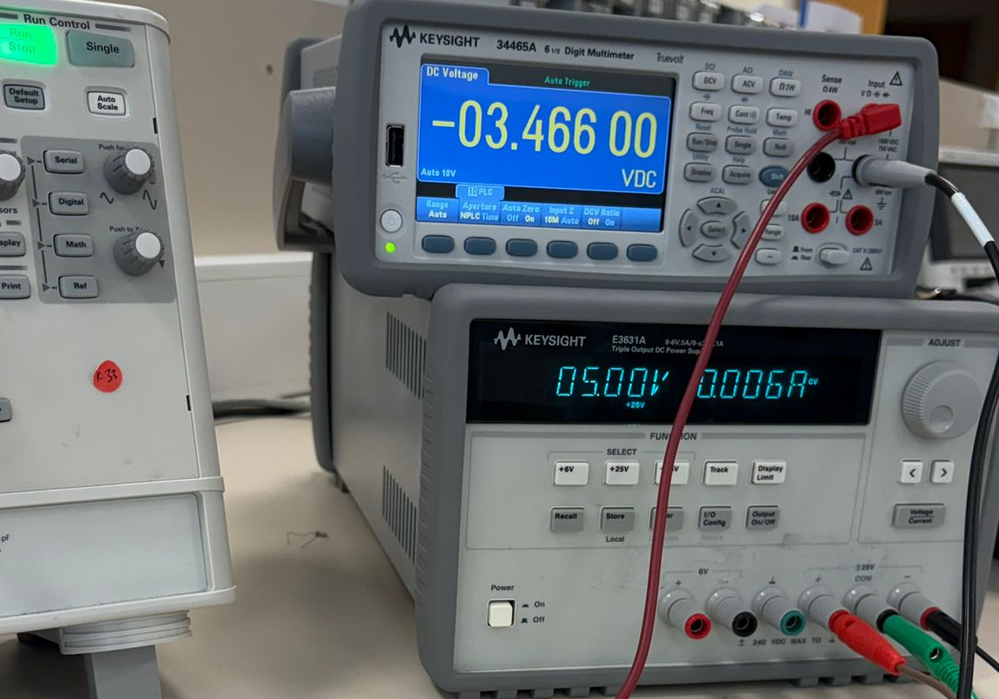
Figure 11: Voltage at the source terminal
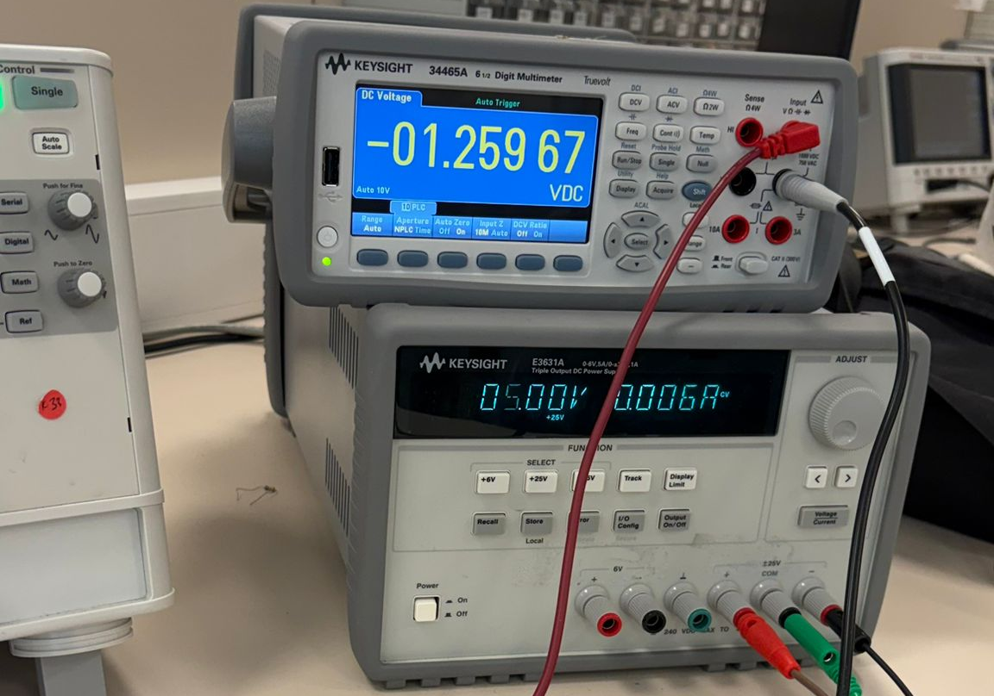
Figure 12: Voltage at the drain terminal.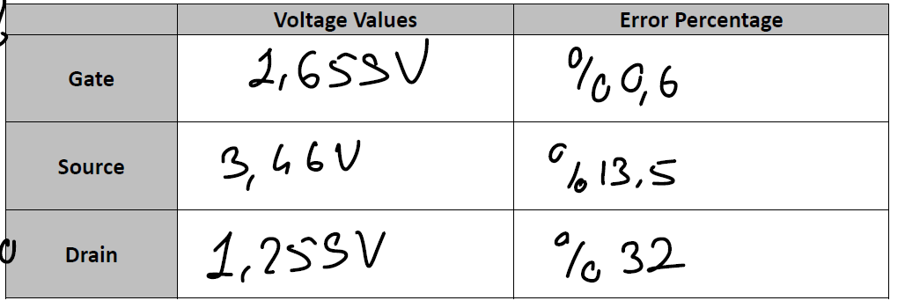
After that, sinusoidal input voltage at frequency of 1kHz is applied from the signal generator and measured using oscilloscope.
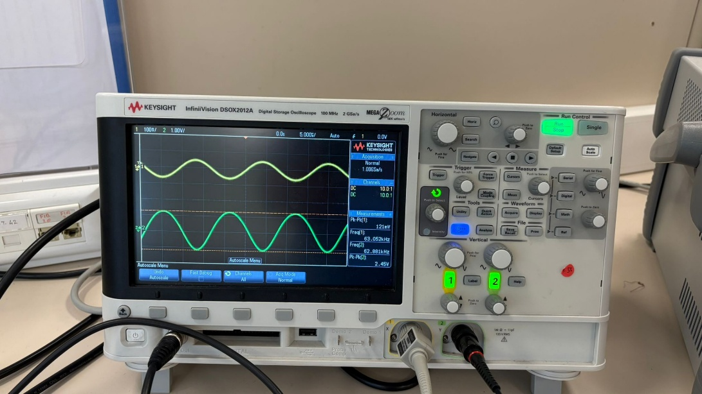
Figure 13: Gain of the circuit
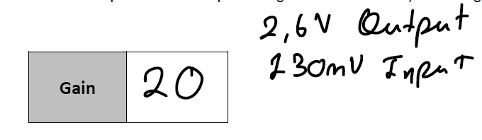
Then input voltage is adjusted to get a result without clipping and distortion and from the measurements gain is calculated and error percentage is computed. Also measured at different frequencies and bode plot sketched according to measurements.
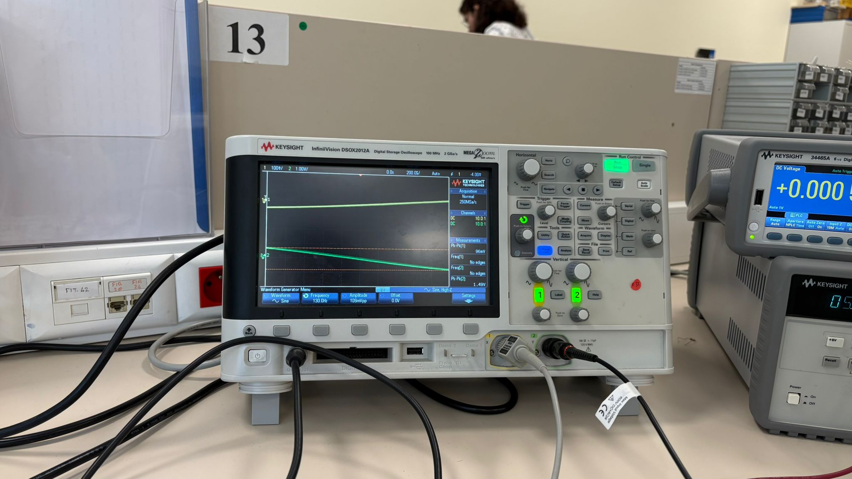
Figure 14: Lower 3-dB point at 130Hz
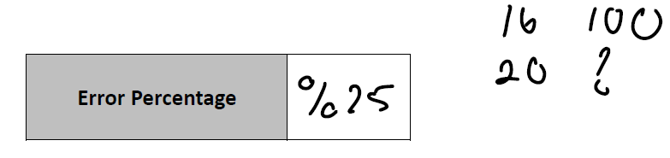
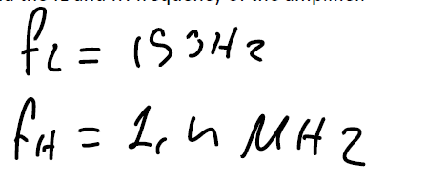
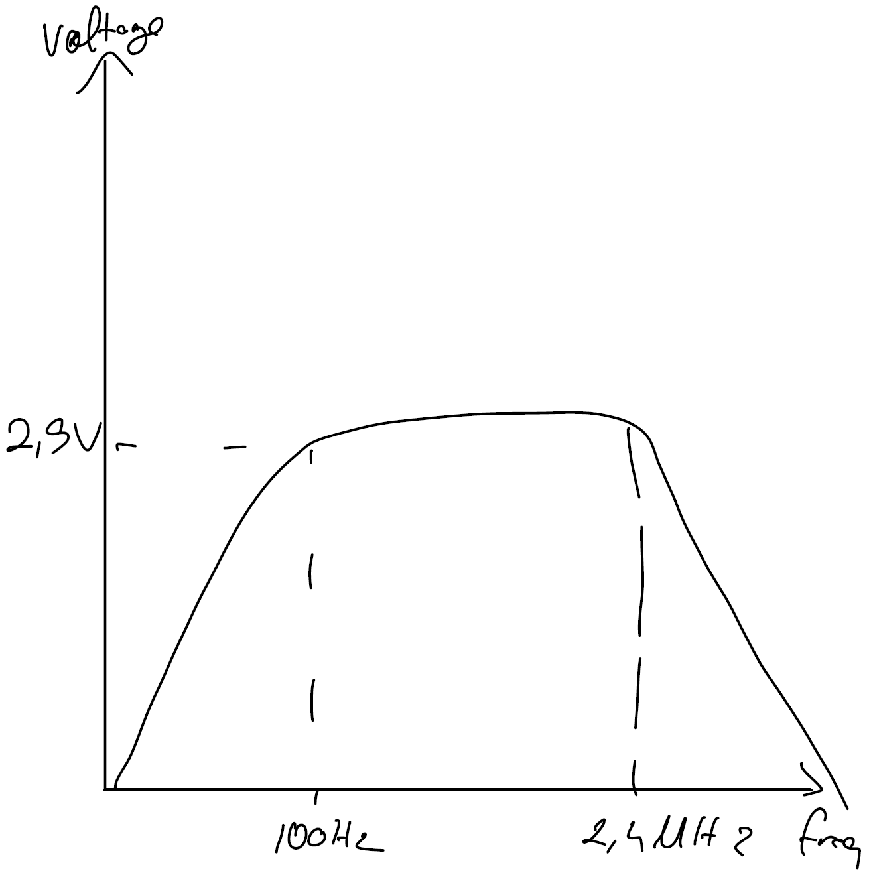
4. Discussion / Analysis
The experiment focused on evaluating the DC and AC characteristics of the BS170 NMOS transistor and its application in a common-source amplifier circuit. In the first part, the threshold voltage and conduction parameter were extracted from the measured I-V data. These extracted values provided a basis for the subsequent amplifier design. During the implementation of the common-source amplifier, the measured DC node voltages at the gate, source, and drain terminals aligned with the theoretical predictions, verifying the correct establishment of the quiescent operating point. When a 1 kHz sinusoidal signal was applied, the circuit amplified the input signal as expected, without clipping or distortion. The experimental voltage gain was calculated and compared to the theoretical value. Measuring the gain across a range of frequencies allowed for the construction of a Bode plot, which illustrated the frequency response and defined the bandwidth limits of the amplifier. The minor discrepancies between the theoretical and experimental results were likely caused by component tolerances, inherent device variations from the nominal models, and physical setup constraints such as breadboard and wire resistance.
5. Conclusion
This laboratory session demonstrated the extraction of MOSFET parameters and the practical operation of a common-source amplifier. The threshold voltage and conduction parameter of the BS170 transistor were determined. The construction and analysis of the common-source amplifier provided practical verification of DC biasing and small-signal AC amplification principles. The experimental voltage gain and frequency response, visualized through the Bode plot, were consistent with theoretical expectations. Despite minor deviations due to non-ideal component characteristics, the results validated the core concepts of MOSFET operation and transistor amplifier design.

